Parking lot USB exercise

Scenario
Review the following scenario. Then complete the step-by-step instructions.
You are part of the security team at Rhetorical Hospital and arrive to work one morning. On the ground of the parking lot, you find a USB stick with the hospital's logo printed on it. There’s no one else around who might have dropped it, so you decide to pick it up out of curiosity.
You bring the USB drive back to your office where the team has virtualization software installed on a workstation. Virtualization software can be used for this very purpose because it’s one of the only ways to safely investigate an unfamiliar USB stick. The software works by running a simulated instance of the computer on the same workstation. This simulation isn’t connected to other files or networks, so the USB drive can’t affect other systems if it happens to be infected with malicious software.
Contents:
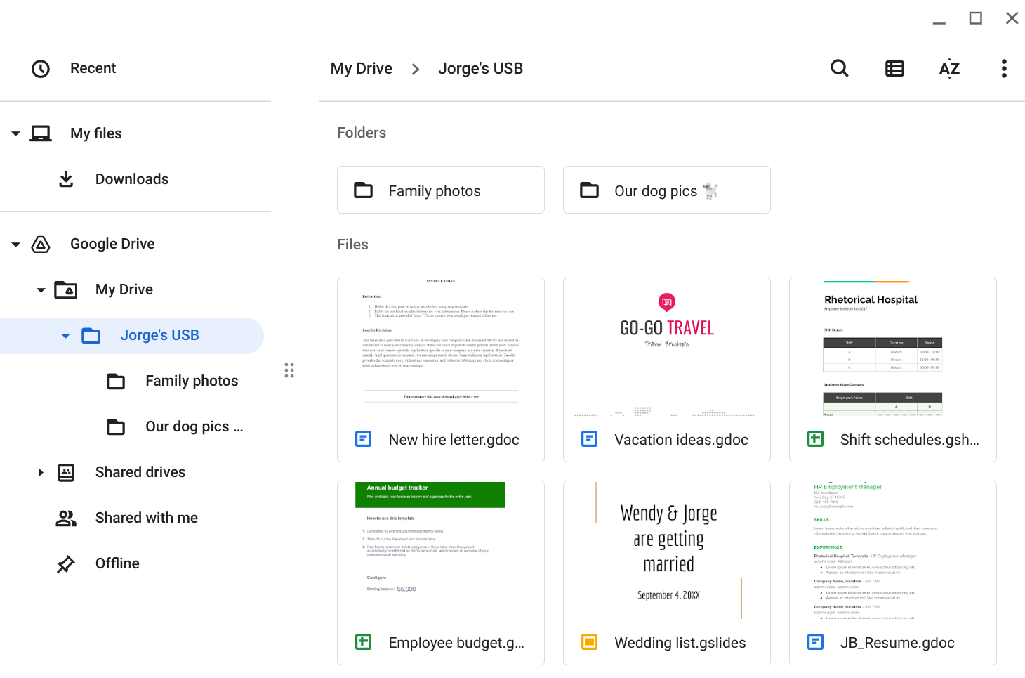

Contents | Write 2-3 sentences about the types of information found on this device.  - Are there files that can contain PII?  - Are there sensitive work files?  - Is it safe to store personal files with work files?  PII: Employee Budget, New Hire Letter, Shift Schedule, Resume, Wedding List  All of these files are sensitve  It is not safe to store work and personal files together as the compromise of one compromises the other
Attacker mindset | Write 2-3 sentences about how this information could be used against Jorge or the hospital.  - Could the information be used against other employees?  - Could the information be used against relatives?  - Could the information provide access to the business?  Attacker Mindset: PII can give me insight into what departments the target has accesss  Wedding list shows individual’s social network, could lead to other high-value targets for recon and exploitation  Shift Scehdule could be used to impersonate member and gain unauthorised access(specifically admin or management profiles)
Risk analysis | Write 3 or 4 sentences describing technical, operational, or managerial controls that could mitigate these types of attacks:  - What types of malicious software could be hidden on these devices? What could have happened if the device were infected and discovered by another employee?  - What sensitive information could a threat actor find on a device like this?  - How might that information be used against an individual or an organization?  Possible Malware: program that modifies registry to have a network backdoor, specifically on admin account/hardware  PII from resume or shift schedule can be used for impersonation and decoy of actual attackers  Compromised individuals can be influeneced to sabotage, physical or digital assets through bribery and complicity in forgery

